**I- BUSINESS**

* Business Name: Sunymus
* Business Logo: 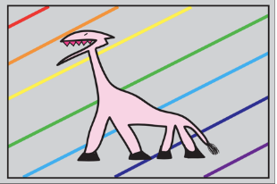
* Business Slogan : Top shoes you can ever find!
* Business Description:All our sneakers are unauthorised authentic, that means made of the exact same materials and stitching/packaging as retail paris just not as authentic and not licensed to manufacture. In other words, their identical to what you get from other official retail store that also includes accessories/laces if any.
* Business Description (What are the categories of products you sell)： Nike Air, Adidas Human, Balenciaga, Givenchy, Nike Air More Uptempo, Adidas Ultraboost, Adidas Prophere, Adidas Yeezy Boost, Adidas ZX500, Adidas Ozweego, Adidas Falcon, Adidas Sense 4D, Nike Air HuaracheI…(Sneakers, Sports shoes, Skateboarding shoes)

**II- SUPPLIERS**

* Suppliers Name or company: Several suppliers but not only wechat
* Suppliers informations (contact I only have her wechat, mail, website (no website)
* Suppliers Products and Services and Pricing :

You should find many good suppliers do not only focus on one (in case of out of stock).

You should save all the informations related to customer in your phone contact or excel workbook .

You can use an identifier related to your supplier (For example : S0001-Sun yao S for ; SCN001 ; SCNSHOE0001) S= Supplier ; CN = China Based Supplier; SHOE = Shoes) You can decide your supplier reference code according to your needs.

**III-PRODUCTS CATALOG**

* Products details (characteristics, pictures, ....)
* Products suppliers (Where a buy this product, What supplier(s))

You should have all the informations related to the product . Many suppliers can provide the same product

You should have a very organized folder and sub folder for your products and pictures. (For example : Sun Yao Elegance Store > Shoes > Sneakers > Jordan > Air Jordan 11 retro

You can use identifier to regroup give reference to products having something in common

**IV-CUSTOMERS & SELLING PLATFORM (SOON)**